MOVIE BOOKING APPLICATION SCREENSHOTS

HOME PAGE:

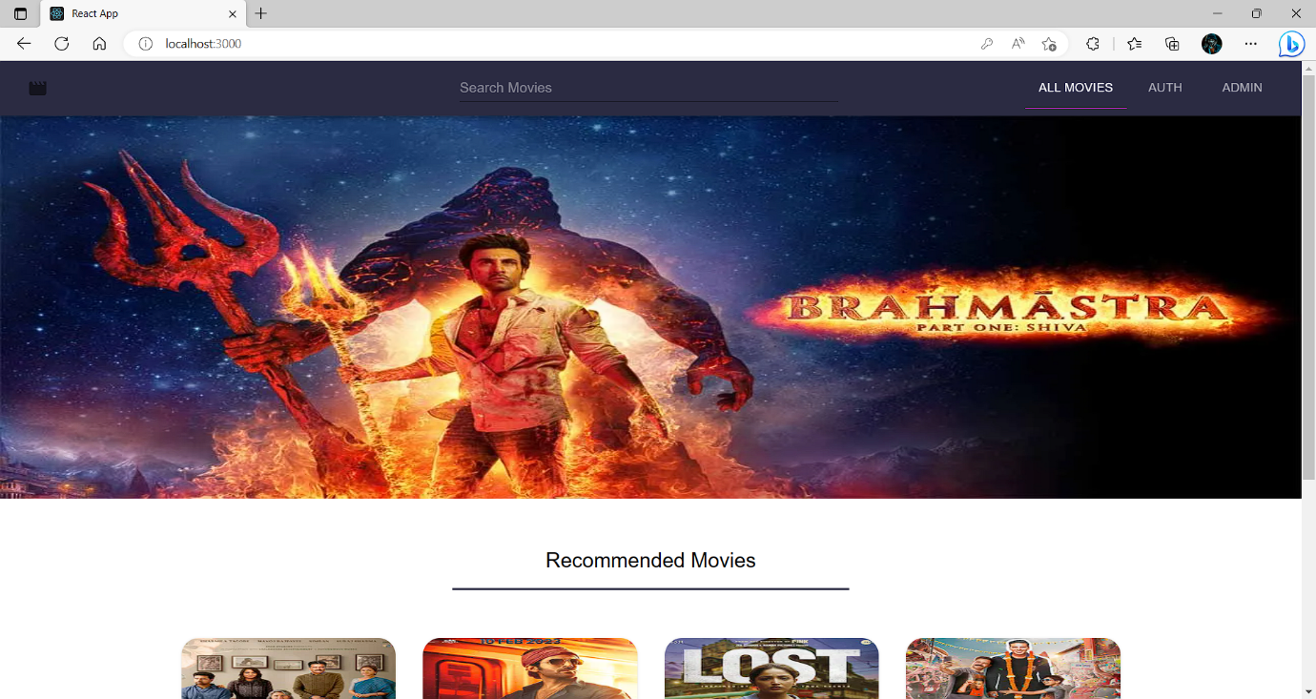

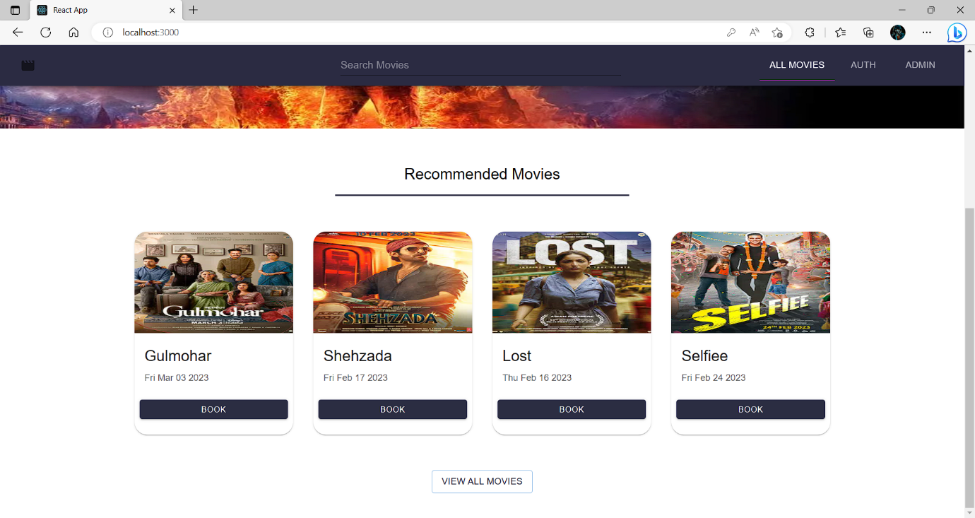

LOGIN PAGE:

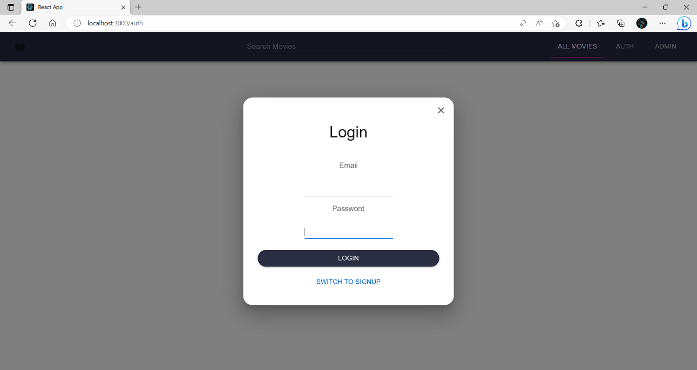

BOOKING PAGE:

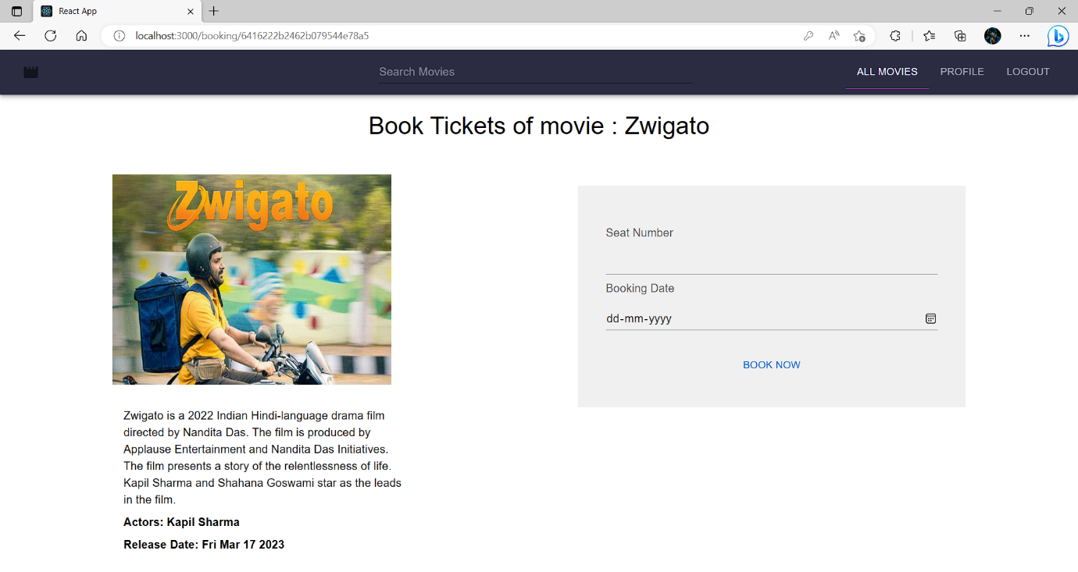

PROFILE & BOOKINGS:

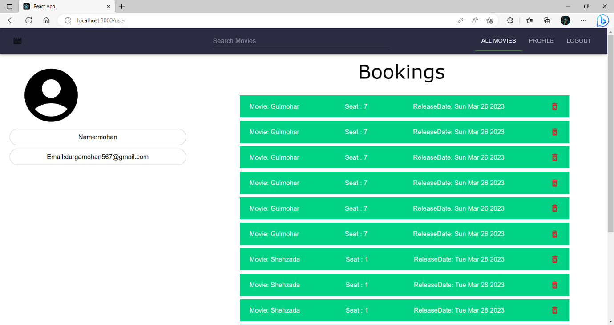

ADD MOVIES:

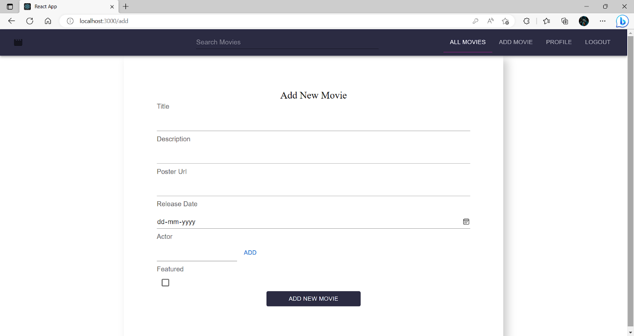

ALL MOVIES:

